SAMPLE CRQ Set 1 Directions (1–3): Analyze the documents and answer the short-answer questions that follow each document in the space provided. Base your answer to Document 1 below and on your knowledge of social studies.

Document #1
An excerpt from The Ascent of Man, Before the Neolithic Revolution
… Man survived the fierce test of the Ice Ages because he had the flexibility of mind to recognize interventions and to turn them into community property. Evidently the Ice Ages worked a profound change in the way man could live. They forced him to depend less on plants and more on animals. The rigorous of hunting on the edge of the ice also changed the strategy of hunting. It became less attractive to stalk single animals, however large. The better alternative was to follow herds and not to lose them – to learn to anticipate and in the end to adopt their habits, including their wandering migrations. This is a peculiar adaptation – the trans-humance [nomadic] mode of life on the move. It has some of the earlier qualities of hunting, because it is a pursuit; the place and the pace are set by the food animal. And it has some of the later qualities of herding, because the animal is tended, and as it were, stored as a mobile reservoir of food…
- Jacob Bronowski, The Ascent of Man, Little, Brown and Company
1. Explain the historical circumstances that led to the developments occurring during this time period as described in this excerpt. [2]
__________________________________________________________________
__________________________________________________________________
__________________________________________________________________
__________________________________________________________________
__________________________________________________________________
__________________________________________________________________
__________________________________________________________________
Document #2

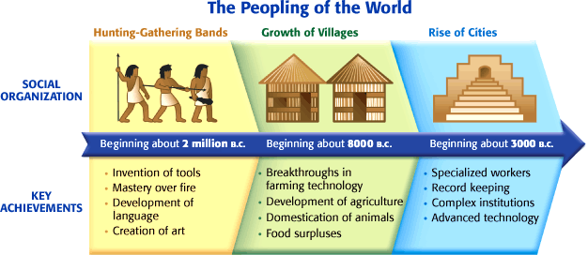

Historical Context: refers to the historical circumstances that led to this event/idea/historical development.

2. Based on this timeline, explain the historical circumstances that led to the Neolithic Revolution. [4]

__________________________________________________________________

__________________________________________________________________

__________________________________________________________________

__________________________________________________________________

__________________________________________________________________

__________________________________________________________________

__________________________________________________________________

__________________________________________________________________
3. Identify AND explain a cause-and-effect relationship between the events and/or ideas found in these documents.

Be sure to use evidence from both Document 1 and 2 in your response. [4]

__________________________________________________________________

__________________________________________________________________

__________________________________________________________________

__________________________________________________________________

__________________________________________________________________

__________________________________________________________________

__________________________________________________________________

____________________________________________________________

__________________________________________________________________

__________________________________________________________________

__________________________________________________________________

__________________________________________________________________

__________________________________________________________________

__________________________________________________________________

__________________________________________________________________

